24. Variation and Microevolution (2) (*RHM: Chapter 21*)

______________________________________________________________________________

VIII. The Hardy‑Weinberg Model *(481-483)*

A. Sexual Reproduction and the Shuffling of Genes

B. Does the shuffling of genes produce evolution?

C. The Model

Under a set of assumptions defined in class, the Hardy‑Weinberg theorem of genetic equilibrium predicts that (1) one generation of random mating establishes binomial genotype frequencies in a population; (2) these genotype frequencies will not change in the population in subsequent genera­tions; and (3) the allele (= gene) frequencies never change in the population from one generation to another.

IX. How Do Populations Evolve?

A. Relaxation of Assumptions of Equilibrium Theory

B. Four Primary Agents of Evolution:

1. Mutation

2. Gene flow

3. Natural Selection

4. Genetic drift

X. Mutation *(482-484)*

A. Definition

B. Types of Mutations

1. Chromosome alterations

2. Point mutations

C. Causes of Mutations

D. Natural Mutation Rates

XI. Gene Flow *(484-485)*

A. Definition

B. Dispersal as a Mechanism Promoting Gene Flow

C. Effects of Gene Flow

24-1

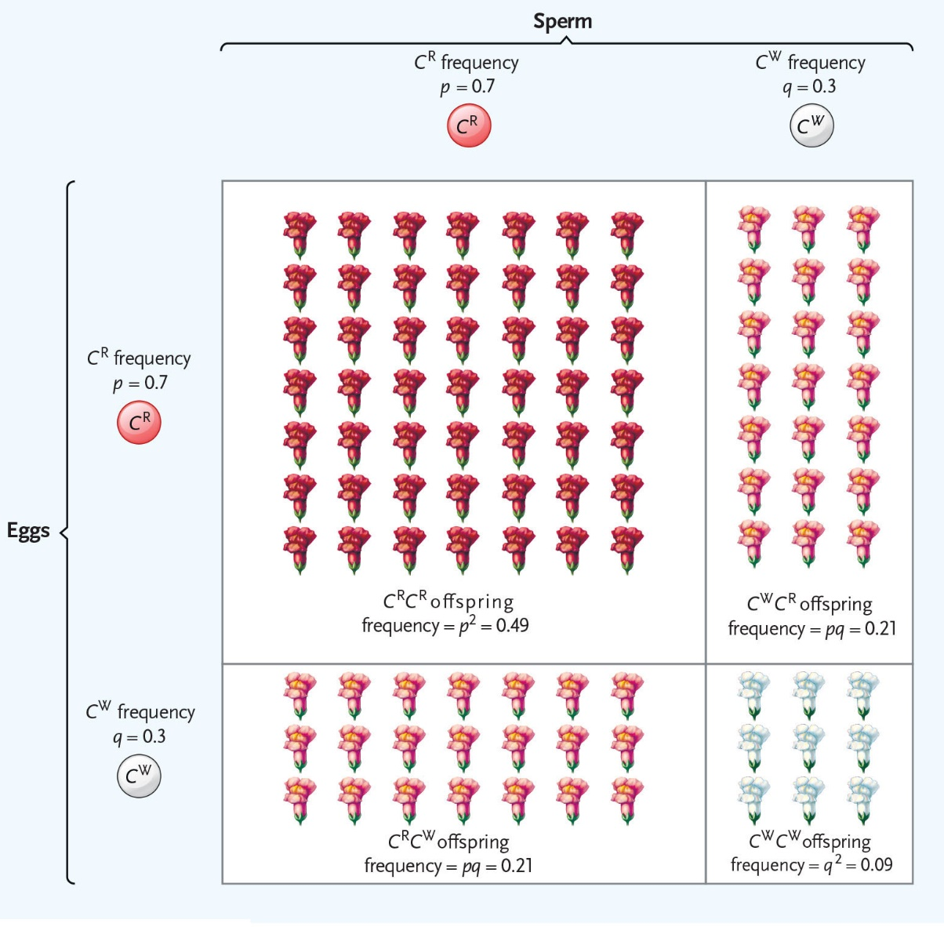

PRACTICE PROBLEMS:

Convince yourself (algebraically) that the above theorem is true by calcu­lating the allele frequencies and genotype frequencies in two subsequent generations if you start with the following parental genotype frequencies:

1) D = 0.90 and R = 0.10 (What about H?)

2) D = 0.10, H = 0.20, and R = 0.70

24-2

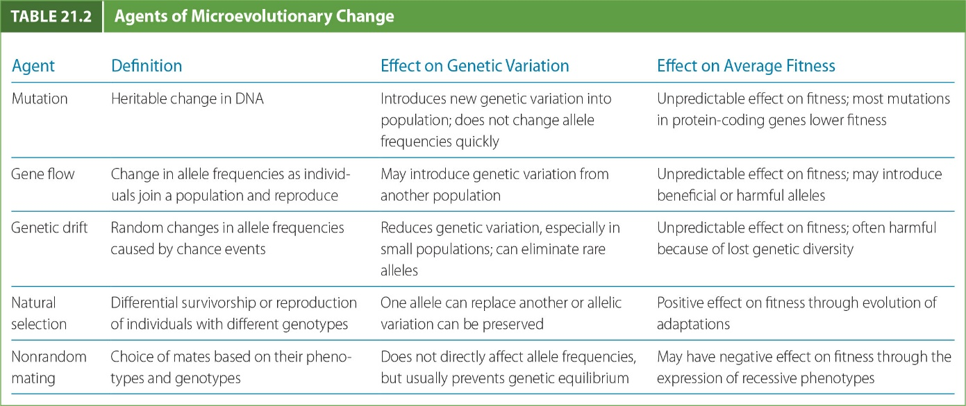

**MUTATIONS -** Large Scale Chromosome Alterations

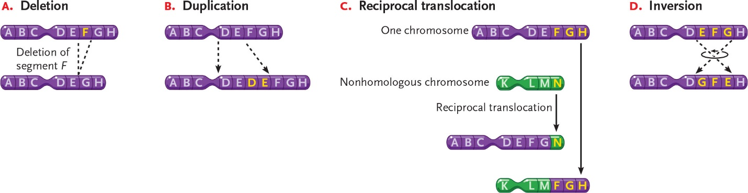

24-3

**MUTATIONS -** Point Mutations

